TVE20MUD001
AKSHAY V
Enlivening Industrial District- Case of Eloor
Urban expansion of Kochi has been seen in Eloor. Kakkanad and Kalamassery are suburbs with wider development potential. Eloor is the largest industrial belt in Kerala, to the south of Kalamassery and to the west of the Cheranallor. The industrial district houses companies like FACT, Apollo Tyers and HMT Kalamassery now in the process of urbanization and act as a transition space. Cheranallor is also in the way of development after the introduction of container road. This region supports the development of various uses such as residential, commercial, institutional, recreational, administrative and industrial. Hence there is a large scope for developing this region as a model for a mixed-use district to support the future growth of the city.
The industries in Eloor polluted the Periyar river and the water bodies of Eloor. Due to the pollution from the industries, the liveability criteria of that region are at stake. Which resulted in the low real estate in this region. Some of the industries are left vacant and the revival of such properties by urban renewal or adaptive re-use is to be done to revitalize the area. Urban regeneration of this brownfield is necessary for increasing the liveability of Eloor and also to contribute to the city as Eloor is in the urban vicinity and the urban expansion of Kochi is projected to see in the coming future. This study attempts to solve the liveability criteria of Eloor and also develop the brownfield into an active neighbourhood.

Keywords: Liveability, Urban renewal, Urban regeneration, Adaptive re-use, Urban Expansion

Re-inventing Changanassery Market as the Eastern Gateway of Kuttanad

Alen Joseph James Guides : Dr. Manoj Kumar K, Prof. Sharat Sunder R

TVE20MUD002
Abstract
Since 1980s Kerala state is one of the most popular tourist destinations in the country. Till date the industry was focussing on to tourism projects and destinations. Recently, the focus has shifted to experiential trials of Kerala to explore its unique culture and traditions, coupled with its varied demography and scenic beauty. So it becomes critical that the identity of a place is retained and all tangible and intangible assets have to be integrated while developing an area. Changanassery region though one among the oldest revenue divisions of Kerala state, has not been on the fore-front of the tourism sector. In this process of urbanisation many of the traditional nodes have became obselete and many of nodes designed for particular functions has been ceased, causing urban decay. Changanassery is one such case, Changanassery market was a designed node which is on the midway of trade route from high ranges to Alleppey with varying built typologies and markets which over time got obselete. Same time Alleppey reinvented as a tourism Gate way to kuttanad. The cultural landscapes of Kuttanad is still being explored only from the north and lower areas and not from the Kayal and Upper regions of Vembanad. The vision of extending the tourism nerve of the Vembanad lake region will re-establish the social, historical, cultural, and significant heritage value of Lower Kuttanad with Changanassery market as a Gateway by integrating experiential tourism as a primary tool for economic development. The existing typomorphologies of the built form of different uses were deciphered. Aspects influencing the concept of Gateway as the identity of a region are analyzed with the theoretical parameters. Design interventions from literature case studies leads to the formulation of urban design proposals of the context

Key Words: Urban Re-invention, Gateway, Typo Morphology, Experiential Tourism, Urban History

TVE20MUD003 ANJANA P

Regenerative Urbanism
Restructuring underdeveloped industrial precinct through regenerative urbanism: A case of Nallalam, Calicut
Keywords: Peri urban, Industrial territory, Regenerative urbanism
Cities are under the pressure of rapid urbanisation and the uncontrolled developments are affecting the metabolism of the city. According to a survey conducted by Economist Intelligence Unit (EIU) in January 2020, it was found that, 3 cities are there in the list of worlds 10 fast growing urban areas. Kozhikode is ranked 4th with 34.5 % growth in the urban area. The uncontrolled urban growth has transformed its peri urban region like Nallalam to an Industrial area. Nallalam is located 6km from the Calicut town and has Calicut’s main waste dumpsite and treatment plant . The city’s waste dumpsite presents in this peri urban zone also triggered the transformation of this region as an industrial region. The fast and uncontrolled industrial growth has brought a large impact on the ecological and livable aspect of the region.
The thesis aims to restructure this peri urban industrial region of Calicut through regenerative urbanism. It also focuses on integrating the ecological layer with the industrial developments and thus obtaining a balance in the developments. The uncontrolled industrial development in the Nallalam region has affected the livability of its inhabitants. The regenerative urbanisation will help to restructure the whole region to a livable industrial region of the city. Regenerative urbanism helps to achieve a balance between the built, their occupants both manmade and natural systems surrounding.
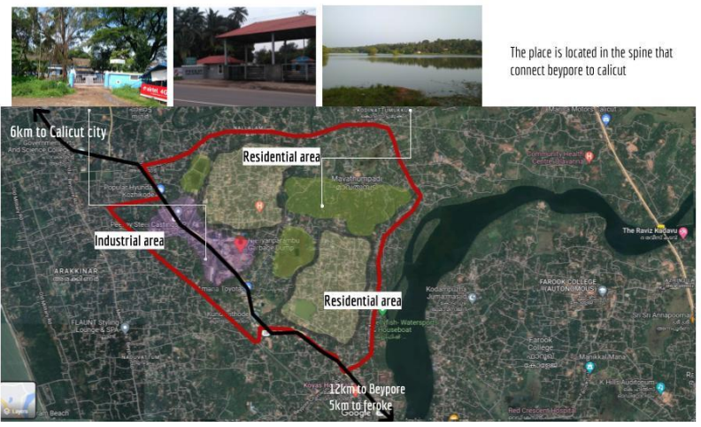
THESIS ABSTRACT
Title: Exploring the concept of Living museum in reclaiming the lost identity of historic towns, Case of Kollam
Ann Hubert, TVEMUD004, Guided by Dr. Manoj Kumar Kini , Adhoc. Prof. Sruthi Satheesan

Urbanisation and globalisation have affected the urban fabric and urban image of several historic
cities. These historic cities that were of greater importance in the past have lost its unique
character and identity, being quelled and forgotten by the urban growth around them, over time.
Due to lack of image to the city and paucity of recognition, the assets in such places are being
left underutilised, making it prone to dilapidation. Such historic cities would ultimately become
characterless, economically weak and globally less known.
The issues in such areas can be solved by branding the history of the place. Living museum can
be used as a tool, using which such places can be branded using heritage. Kollam is the erstwhile
capital of the Venad kingdom. It is the only living historic town of Kerala that has a history of
more than 2000 years, being a flourishing capital over almost 1000 years(829AD to 1740 AD).
Over the years, the city has lost its glory and has become a late back town with very less
economic development and opportunities. By applying the concept of living museum for
branding the place, which would enable tourism, local economy and community, the lost identity
and glory of the place can be revived.
Key words identified: Living museum, tourism, place branding, heritage

REVIVING THE HISTORIC CANAL FRONT THROUGH TEMPORARY
URBANISM: The case of Canolly canal

AYSHA SHERIN A
TVE20MUD005
The thesis is mainly exploring the possibility of Temporary Urbanism along the canal front to reconnect the canal back to the city. As the economic changes in cities, the rise of culture-led initiatives, the social dynamics, climate change and the financial crisis have all added to the increasing interest in temporary uses for urban space. This theory can be used as a tool in Place making, to creates attractive, profitable and active urban space. It can also act as a concrete tool to nourish the bottom up approaches and exploring the potential of the space along the canal to rejuvenate it.Where in older times canal, bridges and streets were used as a major tool to manage development and facilitate the economy in Malabar region. The Canolly Canal functioned as the main infrastructure and had an important role in transportation. The role of the canal was neglected due to the intervention of motor vehicles, soon it started polluting by dumping waste material along. Which caused epidemics for example, typhoid and cholera.The Temporary Urbanism can bring a change to the particular area, which broadly refers to short term, medium term and low cost initiatives that aim to revitalize the local life for economic and social gain. Where the intangible economic benefits to landlords resulting from the increasing the value for their properties, which were otherwise occupied and decay. Also the temporary uses from the minimal to the experiment in the spaces and develop business can result in economic and social flow benefits the communities by incorporating water ways, seasonal activities and pop up markets etc. With a very little impact on the environment. The study is mainly focusing on bringing design interventions as an attempt to reconnect the city dwellers back to the canal in a diverse and meaningful way. There by uplifting the socio economic and environmental condition through temporary urbanism. As the temporary Urbanism, a catalyst for the future development.
Keywords: Temporary Urbanism, Canal front, Regeneration, Place Making

TACTICAL URBANISM AS A TOOL TO REVIVE CULTURALLY DISJOINTED HISTORIC NEIGHBORHOODS

DILJAN CK TVE20MUD006 M4 URBANDESIGN CET

ABSTRACT
The historic neighbourhoods keep many elements of tangible and intangible heritage, which include historic buildings, lifestyles, traditional craft skills, inherited customs, traditions, ceremonial rituals and appearances. Some of the networks may reflect the culture and history of many places. All of this will express the identity and collective memory of that place. Due to urbanization, the expansion of cities and accompanying urban transformations often witness a significant deterioration of culture and historicity, which leads to the loss of identity and spirit of the place, which also disconnects many of the historic neighbourhoods. Restoring those hidden historic layers of the place is needed.
This project aims to link culturally disjointed historic neighbourhoods using tactical urbanism as a tool. Tactical urbanism refers to a rapid, low-cost, and scalable approach to making changes to the urban environment. It is a short-term commitment to a longer-term change. The case taken for the project is two culturally disjointed neighbourhoods in Calicut, which have a strong historic network connecting both neighbourhoods, which is the old procession route with the old bazar area. The intent of the project is to investigate the hidden historic layers of the place as well as the transformations and find ways to link the culturally disjointed historic neighbourhoods considering the people's aspirations, social structure, morphological transformations, and ecological degradation through tactile urbanism.
Keywords: Tactical urbanism, Historic neighbourhoods, culturally disjointed.

TITLE: STRUCTURING SPATIAL DEVELOPMENTS TO ENSURE PUBLIC SPACES IN A FAST TRANSFORMING URBAN PRECINCT: VYTTILA AS A CASE
FAITH ADBUL RASAK ASHARAF
TVE20MUD007

ABSTRACT
Urban areas may be thought of as systems where relatively stable urban structures serve as the foundation for 'flows' of wealth, people, pollutants, cultures, and technology that change more quickly. Populations inside settlements fluctuate, alter in composition, adopt new working and communication styles, etc.
Addressing the infrastructure demands of civilizations requires an understanding of the link between "urban form" and "flows.". Over time and across sectors, there have been a variety of links between the growth of urban form and infrastructure. In certain cases, road construction has resulted in speculative and unplanned growth, while at other times, urban form and transportation infrastructure have been well planned (with new communities centred around train stations and highways). The region is significantly altered as a result of such urban inserts, which alter how the land is utilised, how buildings are used, how people live, how effectively public spaces are maintained, and how many public spaces are accessible to the general public.
Kochi is one of the fastest-growing urban city in Kerala with its urban boundaries expanding over the past few decades. Due to its rapid urbanisation and infrastructural growth, there are several precincts that had been created. Vyttila is one such area that was created as a result of the urbanisation of Kochi. Vyttila is a fast transforming urban precinct with a strong commercial corridor, the Vyttila mobility hub on the east side of Vyttila, and the railway terminal on the north side. The Kaniyampuzha river and Thevara canal flow on the east and west sides of Vyttila respectively having a strong waterfront edge. Despite having such infrastructural developments, the rapid changes in the area have taken place without catering to the need for public space creation. This thesis aims at structuring spatial developments around such fast-changing urban precinct for the development and creation of public spaces taking in the aspects of human-oriented design theories.
Keywords: urban precinct, land use, land management, public spaces, Place Making, Human-oriented Design

TVE20MUD008
JEEVA BENNET
Restorative Urbanism
Weaving Transitional edges to the city through restorative urban strategies – A case of Pondicherry
Keywords: Restorative Urbanism, Transitional edge, Playable city, Inclusive city, Sensory Places

The thesis titled ‘Weaving Canal and Boulevard through Restorative Urbanism – A case of Grand Canal’ aims to weave the blue green transitional edge of the Grand Canal with the built fabric to bring forth socially vibrant, active, playable, inclusive neighbourly community places for social wellbeing. The thesis aims to look into the attributes of restorative urbanism and how they can be implemented to the underutilised canal systems and transitional edges to provide community places for community engagement. Restorative urbanism is built form the theory and empirical research of restorative environment which focusses on how certain places foster recovery from mental fatigue stress and anxiety. It is also built to foster the new global agenda for integrating health and equity within the wider context of city planning. The attributes of restorative city includes green, blue infrastructure, active public places, playable places, inclusive places, sensory places and neighbourly blocks that promote interaction and social activities. The thesis aims to put forward restorative urban strategies that can be applied through urban design interventions to provide restorative transitional edges through the urban regeneration of the Grand Canal Pondicherry integrating the contextual and local aspirations with the ecological functions of the canal.
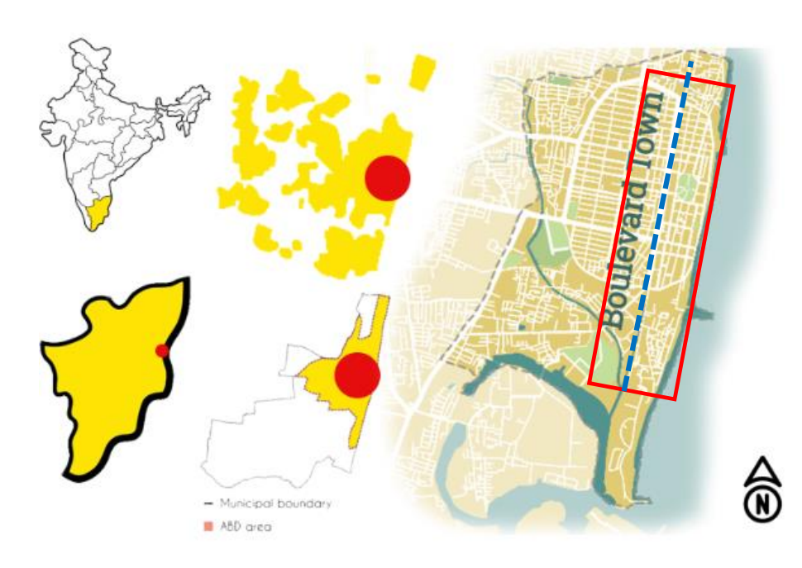

KEERTHANA S K | Dr. Bejene S. Kothari
Reviving the urban identity through ‘place-led developments’- Case of traditional core of Mangalore
Mangalore is one of the fastest-growing cities in Karnataka. It developed as a port city, currently the administrative headquarters of the Dakshina Kannada district, and is also a commercial, industrial, educational, healthcare and start-up hub. Mangalore core seems to be highly disconnected from the rest of the developments. The core holds much of the cultural experiences of Mangalore, such as cuisines, fishing activities, port activities, religious precincts, and a historical market. Mangalore is located on a fertile backwater at the convergence of the Netravati and Gurupura rivers. Fisheries and port activities have been the major factors in developing the city core. The current city developments are highly detached from the potential of its natural assets. Hence, the thesis aims to reverse this by reimagining the current retail core through a new cultural core and religious identity, which connects Mangalore to the riverfront with commercial and public activities. The main goal is to connect the waterfront to the city. Currently, developments are happening without considering the immense possibilities that Mangalore has to offer. The thesis investigates the causes of the existing state of decay in Mangalore's urban core, as well as the potential for reviving its social, cultural, and economic conditions through spatial developments. The project emphasizes place-led development and the significance of identity in urban revival. The study aims to utilize these potentials to revive the identity of Mangalore.
Keywords: Place-led development, urban revival, urban identity, socio-cultural factors

Thesis Abstract | TVE20MUD010
Mahalakshmi P| Prof. Roshni KV
Working title: Revamping the resettlement colony through inclusive urbanism : a case of Kannagi Nagar, Chennai.
Chennai, India’s fourth-largest metropolis is globalizing that includes urban renewal in the center and large Special Economic Zones in the periphery. The latter is also the site of resettlement colonies of evicted people. Resettlement, as a consequence of the government pursuing rapid economic growth via urban renewal, has multi-dimensional impacts. One of the main impacts is on their livelihoods. They depend on the opportunities in the places of their prior social and economic networks; from the places where they were evicted. This dependence also influences the return movement of people from the resettlement colony. Resettlement leads to formation of forcedly displaced communities.
The main concern regarding the resettlement program and schemes is about the approach of accommodating the re-settlers rather than concentrating on providing healthy and better living conditions as a whole. That is the place where the need for urban designers comes.
One such precinct is Kannagi Nagar, one of the largest built resettlement sites in India, housing over 80,000 people. Dwellers face many issues regarding a healthy environment, infrastructure, and facilities and the site is also distant from their workplaces.
Hence, the major idea of the thesis is about the spatial design perspective change from simply accommodating the population than to ensure urban equity and equality for the forcedly displaced communities through inclusive urbanism.
Key words: metropolis, resettlement, inclusive urbanism, sense of belonging, urban equity and equality

Working Title:
RE – IMAGINING THE ANCIENT PORT TOWN OF BEYPORE AS A GATEWAY TO MALABAR REGION
Thesis
Submitted by: Manna Maria Nixon _ M. arch (Urban Design) _ College of Engineering Trivandrum
ABSTRACT
Port towns are strongly and historically linked. But the link between the city, the port and its water connectivity are becoming weaker due to the various urban issues in Port towns. This is affecting the blue economy and the city's economic conditions. Port towns are the major area for cultural exchange, trade and development. This physical and socio-economic degradation can affect the changing urban fabric and culture, communities, ecology, etc. They are the forefront of many contemporary issues such as migration, climate change, digitization etc. The natural blue- green system can be a barrier and thus it can create disjunct precincts, make it laid back zones from the city.
There is a need to preserve the values of historic urban landscape and the intangible lifestyle related to it while rehabilitating, renovating or reconstructing the city’s historic urban legacies for economic benefits. Thus, it lost its identity and spirit, which led to obsolete situation in port towns. This problem cannot be traced to as a single reason or cause; rather it represents a combination of economic, cultural, social, and environmental circumstances that take up the spatial character and form in the port towns. There is a need to understand the path dependencies that shape how we engage with water today, which is suitable for the regional setting and can create sustainable development considering the economic growth.
Economic and technical advances have profoundly reorganized ports around the world, dramatically affecting the relationship between city and the port, the images and representations of the cities they area in, and the living and working conditions of those who live and work near ports. But most of the ports still remain underdeveloped due to the lack of proper investments and usage. These ports are living organisms which connects the land and water. The historical connections between towns and waterscapes are intricate and frequently only understood through technical explanations. Understanding how human- centered innovations have changed how river areas and sea are used over time and how these changes affect the values of rivers and the cultures around them is crucial. There is a need to understand this water culture and its influence on the urban fabric and multidisciplinary fields like ecology, culture, social structure, economy, etc. The research reflects on the analysis of the impacts of how the port towns can be the stewards of future water and heritage practices. The study thus analyses current concept and projects which is related to the blue sustainable tourism of Port towns in major cities, emphasizing the key strategies for executing it.

Keywords: waterfront, economic growth, blue sustainable tourism

RELIGIOUS TOURISM AS A TOOL IN REJUVINATING OF SMALL TOWN – A CASE OF CHOTTANIKKARA TEMPLE AND PRECINCT
SUBMITTED BY – NIJASMON K S

ABSTRACT
‘Tirthayatra’, Pilgrimage in Indian essence, is ‘undertaking a journey to a religious area, In India, a majority of religious places are extensively associated with nature and surroundings. Pilgrimage travel to these spirituality epitomes is reported to have substantially increased in the past few decades due to increased accessibility. This is also due to the improvement in Transport infrastructure and mobility. The New age version of the pilgrim area caters to the more modern scenario, displays more ‘tourism like’ characteristics including changing patterns of visits, limiting the engagement of tourists with rituals, commercializing the organization typical to package tours and travel, and a particular way. Apart from its festivities and special purpose, its surroundings also play a major role in making a pilgrimage centre famous. Therefore, urban development is an important factor. The Chottnikkara Devi Temple is a famous temple of mother goddess Bhagavati. The temple is located at Chottanikkara, a southern suburb of the city of Kochi. The number of visitors to the temple has increased significantly in recent times. Some facilities are provided by the Devaswom Board; However, they are not adequate. Chottanikkara is one of the most famous temples in India for dealing with mental illnesses and other mental ailments. Many people from Kerala and outside Kerala visit the temple every day for such purposes. The famous Makam Toshal festival and other festivals in the temple are visited by a lot of people. If the existing facilities are improved a little, it will benefit the people who come there, the growth of the temple, and the tourism sector of Kerala. This study is mainly focusing on the development of the Chottanikkara temple area. The key factors are raising the standard of living, increasing commercial potential, efficient infrastructure development, and tourism improvement. Through these elements, the temple strives to become more famous and to more economic growth to Kerala and also provide good facilities for the visitors, and provide a better quality of life to the locals.
Keywords: Pilgrimage, Religious tourism, Spirit of place, Place making

URBAN DESIGN AS A TOOL IN GUIDING THE URBAN REGENERATION OF THE TRANSFORMING CITY’S ENTRY CORRIDOR TO A CREATIVE GATEWAY: CASE OF KAZHAKOOTAM,TRIVANDRUM
Submitted by: Nikhil Suresh | TVE20MUD013
Under the Guidance of Prof. Ashfina T, Prof. Nirmal Chandy Mathew
Abstract:
Cities' entrance should introduce the city or in other words, be a showcase displaying the city's identity and values hidden in it. Unfortunately, criteria and regulations of urbanization have not been observed in cities' entrance design. The entrance of Trivandrum city lacks a clear definition and a clear identity which leaves the people entering unclear whether they have actually arrived in the city or not. Objectives of a city’s entry corridor development are always large: they need to ensure access to transportation, provide high-quality transportation, develop livable communities and provide for economic development along the corridor. With new development along the corridor of the city, the opportunity exists for Trivandrum’s entry corridor to ensure a cohesive and desirable appearance along the highway. Urban regeneration is an urban design approach to sets out principles designed to achieve high-quality buildings, urban infrastructure, public places, and streets that all have one thing in common – they are designed for people and protect the environment along the city’s entry corridor.The thesis attempts to provide frameworks that guide ongoing development and urban renewal to ensure it benefits the city. Also, attempts to deliver a gateway corridor of improved quality of the public domain and buildings and additional employment and recreation opportunities.

PREJILY THOMAS JOHN
TVE20MUD014

Rethinking everyday urban spaces through principles of resilient urbanism, a case of flooding in Thiruvalla
Keywords: everyday urban spaces, flood resilience, resilient urbanism
Flooding of urban areas often has an adverse impact on the dense population residing in cities. The vulnerable areas are the most affected due to flooding and even results in loss of life. Increasing trend of urban floods is a universal phenomenon and leads to a vital loss in the physical, economic, social and environmental dimensions. The shift from floods being a natural disaster to a man-made disaster due to unplanned urban growth is evident from the national and international reports.
Thiruvalla, bordered by Manimala River in Pathanamthitta district is an important urban node and a drainage point of various estuaries. The city is often faced by flash floods and overflow from rivers since it is a low-lying land. The need for urban flood resilience for a planned urban development is a necessity for liveability in consideration with the topography.
The thesis focuses on developing urban design framework in the everyday urban spaces through the principles of resilient urbanism. The principles guide towards the creation of flood resilient spaces and productive urban landscapes for the city to enable better and safer living conditions. A flood resilient city not only to prepare the city for disasters but also to improve the ecological and economic conditions.

Thesis:
CREATING CONVIVIAL SPACES IN URBAN VILLAGES THROUGH COMMUNITY LED URBAN REGENERATION: Case of Vypin
Serene Meccartin | Guide : Ar. Prajitha T K
ABSTRACT
In the scenario of rapid urbanization, cities currently witness the vanishing of effective public openspaces. One of the most affected zones in a city are the urban villages and are often neglected in theprocess of urban development. Even though urban villages bring in potential developments for the city; it can undergo rapid transformations that make the place fragmented or even lose its characteristic and identity of the place. This eventually leads to decline the quality of effective public spaces in the context. In a city like Kochi, the place is transforming to be highly saturated and open spaces which act as the social platform for recreation are diminishing or are confined within the city core than its peripheral premises. Vypin act as an urban village for Kochi city and is undergoing rapid changes due to the insert of new connections and transport modes in the coastal region. It is becoming the next alternative destination because places like Kakkanad, Maradu, Tripunithura and Kalamassery have become saturated and unaffordable. Urban regeneration is an approach in urban design to repair the social and economic problems of an urban area. Community-led urban regeneration points out the importance of communities and their role in the process of development. Understanding their needs and issues faced by them and implementing design strategies helps to build sustainable communities and effective public spaces. Thus it act as an effective tool to create convivial spaces in fast growing urban villages. The thesis attempts to understand the importance of urban villages and identify the issues its communities face in the scenario of urban development. The study aims to identify the components of urban village and effective public spaces and tries to analyse the same through some case examples and appreciate the same on site. Through the theory of community led urban regeneration, the thesis focuses to reconnect people and their communities by inserting urban design strategies.
Keywords: Community led regeneration, Urban Village, Conviviality, Vypin

Thesis Abstract
Re-integrating historic lakes into the city fabric Case of Vandiyur Lake, Madurai
Soumya Pugal
TVE20MUD016
Abstract
A tank cascade is a network of surface water holding structures, built more than 2000 years ago by local rulers and maintained since then for centuries by the local communities. A chain of tanks in a cascade forms a micro-watershed wherein an individual tank has its own catchment, tank bed area, and command area. These tanks are often observed interlinked by a common stream flowing under gravity from the upstream tank thereby feeding the downstream tank. The underlying principle behind tank operation is the reuse and recycling of water from a series of small- to large-scale tanks. The catchment or watershed captures and conserves rainwater runoff, which would otherwise flow down as streams and mostly dissipate as evaporation. Rapid urbanisation has led to the disruption of the traditional structure of development sensitive to the needs of the people as well as the environment. To find a balance to the social, ecological and economic needs of the people the concept of placemaking through water sensitive urban design can be explored. This approach re-invents the relationship between the people and the water tanks to suit the modern aspirations. The thesis aims to develop methods to guide the development along the historic urban lake of Vandiyur to equip the lake to meet the growing needs of the city in terms of its recreational needs and provide a renewed connection between people and water. The intent of the project is to understand the ecological as well as the social structure of the lake and find ways to utilize the lake to create social cohesion within the community and balance the economic and ecological needs of the city by the use of placemaking through water sensitive urban design.
Key words: Urban lakes, Urban blue spaces, Placemaking,Revitalisation of lake

HUMANISING THE CONVERGING URBAN TRANSIT NODE: ATTINGAL AS A CASE
Abstract
'Urban node' means a functional area that encompasses one or more core areas, as well as the periurban and regional areas surrounding cities or polycentric city-systems. Due to urbanization many nodes are facing development thrust. And as an uncontrollable result overgrowing of urban nodes is happening everywhere. Especially in an Urban Transit Node which is a converging point of suburbs around it. Attingal is a municipality in Thiruvananthapuram metropolitan area in Thiruvananthapuram district. It is an urban node which is situated geographically in the center of both Thiruvananthapuram and Kollam city core. And the agglomeration of both the cities is towards Attingal. Attingal is primarily a transit node but a functional and cultural node as well. Attingal being the transit point for many towns and cities surrounding it, acting as a bottleneck which creates many issues to the urban usage through land-use impact as well as transit uses such as accessibility, convergence and integration. Speculative design is a design practice that is concerned with future design proposals of a critical nature. A new bypass is a solution in sight to Attingal’s traffic woes but which will cause positive and negative impact to the town. The proposal for shifting of the existing bus stand from the present place to a comparatively less busier outskirts will also create critical results to the town. A Speculative design approach to humanise the Converging Urban Transit Node of Attingal is particularly the thesis intend. Humanising factor-Walkability is more concerned in this thesis. Nodal centers are presented as poles of convergence of the population and functions, from which development impacts — the main factors being environmental, economic and community. This thesis primarily focuses on humanising the Attingal Town. Rethinking it from an overgrown urban node to a well-integrated city that has residential, commercial and service elements within a walkable distance. The key objectives are integrating a mixed-use, compact, transit oriented and multi-modal city through the nodal development.

THESIS TOPIC: CHANALISING PORT IMPOSED DEVELOPMENT PRESSURE IN LOW DENSE AREA- VIZHINJAM A CASE
SUMAYYA S |KTU ID: TVEMUD018|CET
Guides: Dr. Manoj Kumar Kini, Prof. Sruthi S

Abstract
“Ports have traditionally been the centres of economic and cultural activities in cities, if not they are the reason for cities initial development”. Although the link between port and urban growth has attenuated over time it creates many potentials and challenges to the city which it belongs to. The port developments activate the global supply chain, it acts as a facilitator of trade, create investments and job opportunities in various sectors related to the port. For the better performanp;ce of the port, it needs a good relation with the city and vice versa. The introduction of a port can causes suburbanisation and other challenges such as traffic congestion, visual impact, socio cultural impact and ecological impacts as well. Similarly, the port imposed direct as well as indirect effect on the urban fabric.
The Vizhinjam International Transhipment Deepwater Multipurpose Seaport is an ambitious project taken up by Government of Kerala. It is designed primarily to cater container transhipment besides multi-purpose and break bulk cargo. Located in close proximity to the maritime super highway with natural deep-water port, Vizhinjam port triggers development pressure in the low dense coastal areas. The massive urban transformation occur along the fragile land may led to various social issues such as exclusion, inequality, haphazard growth etc. This project tries to develop a master planned-designed port town giving emphasis on inclusive growth, with protecting local livelihood, promoting world class living, recreation and financial districts etc.

• Understanding port-imposed development pressures.
• Understanding the morphology of a port town.
• Developing growth models and functional zoning.
• Developing inclusive design strategy.

GUIDING THE GROWTH OF THE EMERGING COMMERCIAL CORRIDOR OF KOLLAM CITY
Sajeev I Pius (TVE18MUD015)
Abstract
Rapid urbanization in traditional Indian cities puts forth the problem of scarcity of buildable land for future development. The urban core is most commonly populated by economic and commercial activity, and the lack of space for future commercial endeavours greatly hinders the economic progress of the city and the state in general.
This problem often leads to development and urbanization of areas that are out of the city’s commercial core. Parallels could be drawn to the phenomenon of suburban sprawl in the housing sector. This commercial expansion is often times unregulated and unplanned leading to haphazard development that is detrimental to an array of systems, from ecology to transportation, from activity to aesthetics and from safety to accessibility.
The thesis is a study into how urban design theories can be used to guide the growth of newly emerging commercial areas, mainly linear stretches and streets that often times transform to become the commercial and even cultural hub of the city. Regulated and planned growth can foster an image for the street that resonates with the aspirations of the people, the city and the state in a holistic level, in addition to being a generator of employment and a stimulus for commerce and the local economy.
This study can be scaled and adapted to other such cities that face similar hurdles with respect to newly emerging areas of the city. The framework proposed by this thesis is adaptable in contexts similar to India and does not serve as an international model. The scope of the study culminates at the precinct level and serves as the foundation for future research into scalability and adaptability of similar concerns. Integration to the existing urban and economic fabric of the city is also a scope for further study.

